Current Marking on AD8022ARMZ , AD8022ARMZ-REEL, AD8022ARMZ-REEL7, and AD45023Z-REEL Pb-free Device:

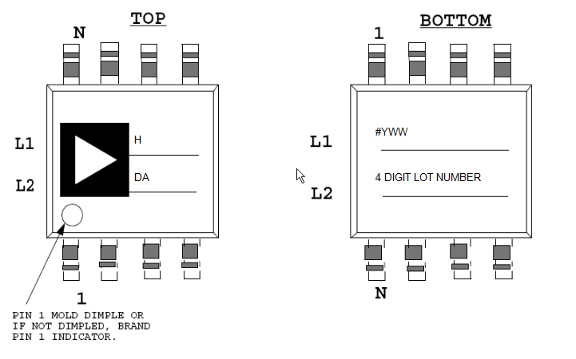

------------------------------------------------------------------------------------------------------------------------------------------

AD8022ARMZ , AD8022ARMZ-REEL, AD8022ARMZ-REEL7, and AD45023Z-REEL Marking will be changing to:

